IRAQ: NGOs urge action on displacement crisis
BAGHDAD, 13 August 2008 (IRIN) - The Iraqi and US governments should do more to address Iraq’s displacement crisis which has affected over four million people and threatens regional stability, a group of Iraqi and international non-governmental organisations (NGOs) has said.
“We… endorse a bolder approach to helping vulnerable Iraqis, especially ones who are displaced. Current US efforts to help Iraqis are a good start, but they don’t go far enough,” said the 8 August statement by scores of NGOs inside and outside Iraq.
“The Iraqi government is responsible for assisting its internally displaced population as well as other vulnerable Iraqis, and all efforts should be made to urge more action and assist its efforts,” it continued.
The statement said many Iraqi refugees in neighbouring countries were struggling to survive as their savings were limited and they did not have the legal right to work; many lived in fear of being forcibly returned to Iraq, and face possible death threats and persecution.
“As their stay in neighbouring countries drags on without any immediate solution in sight, the protection concerns facing these people continue to rise,” the statement said.
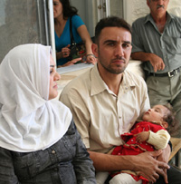
Photo: IMC
Only 4 percent of Iraqis living in Jordan can afford proper medical care
Call for USA to resettle more people
The group praised the US government’s efforts in resettling around 10,000 Iraqi refugees (and the planned resettlement of another 12,000 refugees in 2008), but it said: “The needs are much greater. We ask the US to reconsider resettling 105,500 refugees from Iraq and, if necessary, to reassess this number for the next few years.”
These calls were echoed by Basil al-Azawi, head of the Baghdad-based Commission for Civil Society Enterprises, an umbrella group for more than 1,000 NGOs.
“There is clear negligence by the Iraqi government, other governments and international bodies via-à-vis the needs of the internally displaced persons [IDPs] and refugees in neighbouring countries who are forgotten,” al-Azawi told IRIN.
“Iraq is still a country of conflicts and therefore the most dangerous place in the world,” he said.
Lack of data
The NGO statement said Iraqi institutions should be strengthened to provide improved services to all vulnerable Iraqis, especially IDPs, and prepare comprehensive data.
Al-Azawi blamed the lack of data on the paucity of government offices dealing with IDPs: “There are some families who have not been registered yet because government offices are located in remote areas and they find it hard to reach these offices to register.”
“All actors recognise that [IDP] needs are enormous and unmet. The needs of IDPs and other vulnerable Iraqis are extremely difficult to address, as there is a generalised lack of information and hard data,” the statement said.
sm/ar/cb
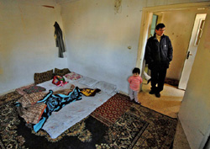
Photo: P.Sands/UNHCR
In Amman, most Iraqi refugees live in very basic and often crowded accommodation

